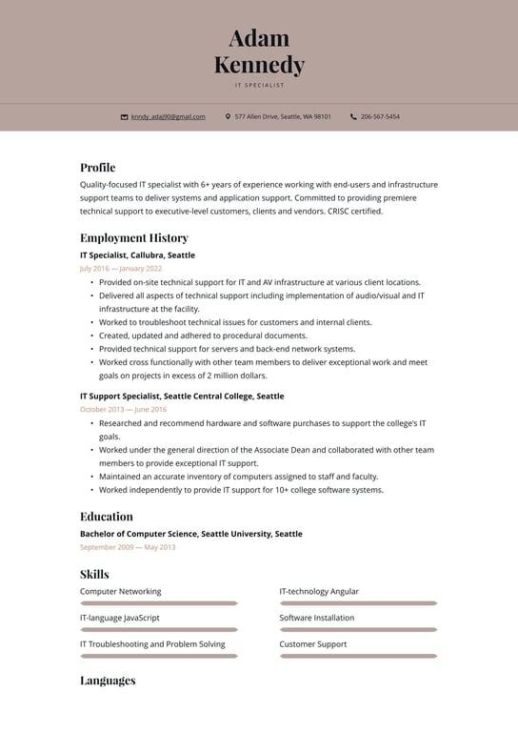
Adam Kennedy
IT SPECIALIST
dadagmail.com
577 Allen Drive, Seattle, WA 98101
206-567-5454
Profile
Quality-focused IT specialist with 6+ years of experience working with end-users and infrastructure support teams to deliver systems and application support, Committed to providing premiere technical support to executive-level customers, clients and vendors, CRISC certified.
Employment History
IT Specialist, Callubra, Seattle
July 2016-January 2022
•Provided on-site technical support for IT and AV infrastructure at various client locations.
• Delivered all aspects of technical support including implementation of audio/visual and IT infrastructure at the facility.
• Worked to troubleshoot technical issues for customers and internal clients.
• Created, updated and adhered to procedural documents.
• Provided technical support for servers and back-end network systems.
• Worked cross functionally with other team members to deliver exceptional work and meet goals on projects in excess of 2 million dollars.
IT Support Specialist, Seattle Central College, Seattle
October 2013-June 2015
⚫ Researched and recommend hardware and software purchases to support the college's IT goals.
• Worked under the general direction of the Associate Dean and collaborated with other team members to provide exceptional IT support.
• Maintained an accurate inventory of computers assigned to staff and faculty.
• Worked independently to provide IT support for 10+ college software systems.
Education
Bachelor of Computer Science, Seattle University, Seattle
September 2009-May 2013
Skills
Computer Networking
IT-technology Angular
IT-language JavaScript
Software Installation
IT Troubleshooting and Problem Solving
Customer Support
Languages

